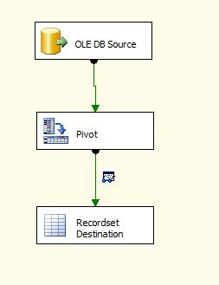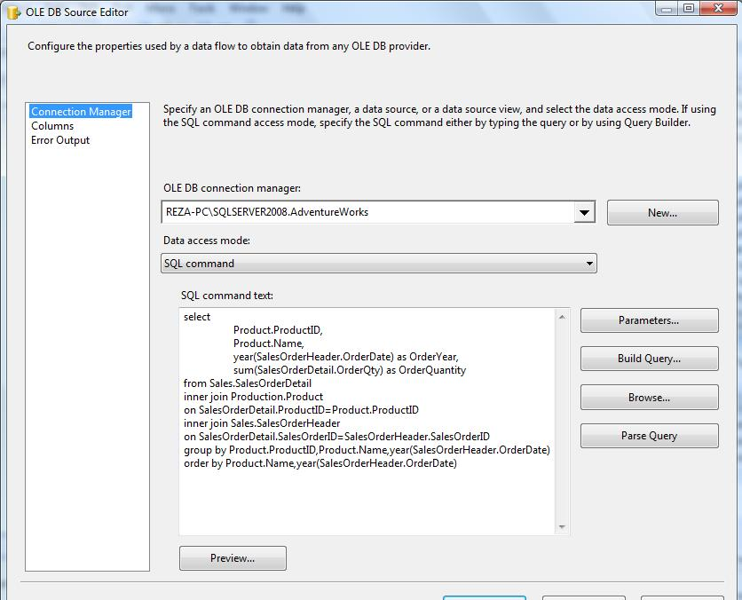

and this is result of query above:

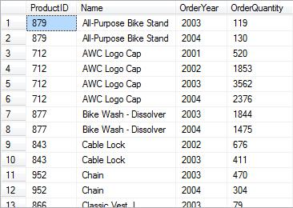

In Pivot transformation advanced editor , go to input columns tab and select all input columns

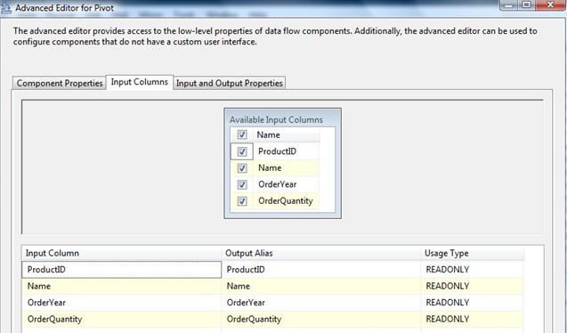

Go to **input and output properties** tab, select pivot default input, under input columns you will find all columns which you selected in previous tab.

the only property you must set for each input column is the **PivotUsage** .

this describe the values you can use in PivotUsage property:

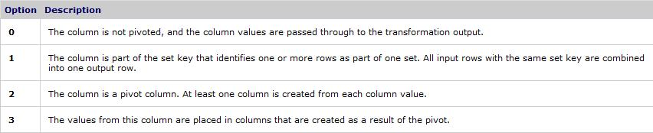

So , in this example , **PivotUsage** property for each input column will be as below:

**ProductID 0  
Name 1  
OrderYear 2  
OrderQuantity 3**

Notice that you must have at least one input column with PivotUsage 2, one input column with PivotUsage 3,one input column with PivotUsage 0 OR 1 at least in your pivot transformation.

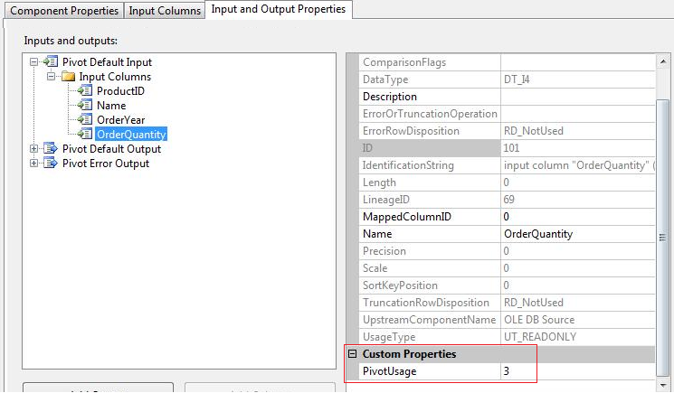

After setting input columns, go to Pivot Default output , and under output columns add these columns:

ID, Name , 2001 ,2002 , 2003 , 2004

ID and Name columns will show the exact values form ProductID and Name input columns.

So, set SourceColumn property of ID output column to LineAgeID of ProductID input column.

Note: this is critical to use the lineageID value of input columns not the ID value. if you use ID value you will face error.

but how can you find lineageID of input columns?

simply select ProductID under input columns and see the lineageID value there.

Note: the lineageID is different on each machine, so you can not use exact lineage numbers used in this example.you must use your lineageID values. This is lineageID of ProductID input column:

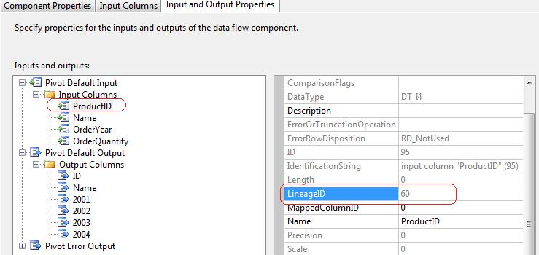

and this is the SourceColumn property in ID output column:

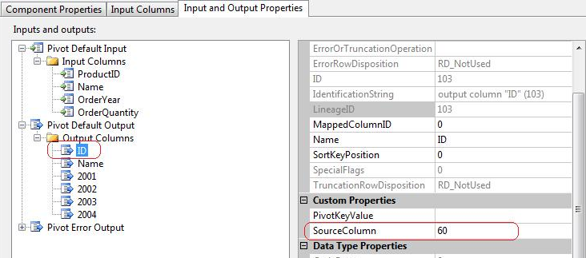

Leave the PivotKeyValue of ID and Name output column as empty.

Do above steps for Name output column with Name input column too

Now it's Pivot columns turn, select 2001 under output columns, this columns will show the results for the year 2001, so enter 2001 in PivotKeyValue property. And set SourceColumn with lineageID of OrderQuantity input column.

In fact you must set SourceColumn property with the lineageID of the input column which has the PivotUsage 3 value.

in this example , lineageID of OrderQuantity is 69 (Remember you must use your own lineageIDs)

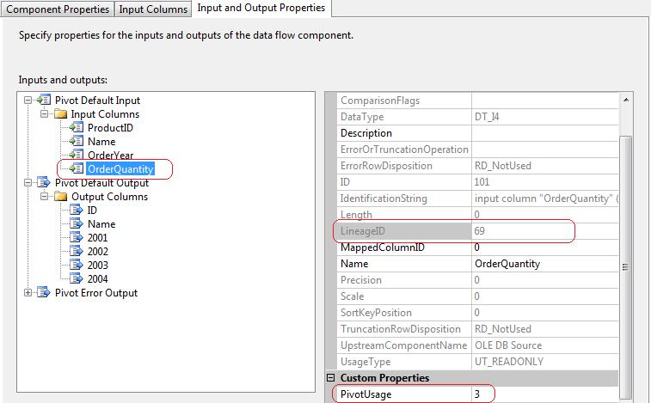

So, we set SourceColumn with 69 in 2001 output column:

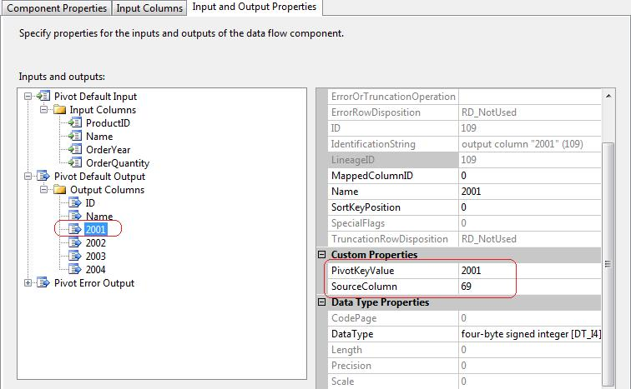

Now , do the same for 2002,2003,2004 columns.the only difference is that you must set PivotKeyValue to 2002,2003,2004 in these columns. but lineageID will be the same in all 2001 - 2004 columns.

Just add a destination, and fill the result of Pivot in destination.

I used a RecodeSet Destination with a Grid Data Viewer to show the result, you can add Grid dataviewer by right click on green arrow between pivot transformation and your destination, then select data viewers, then add Grid.

And this is the final Result:

